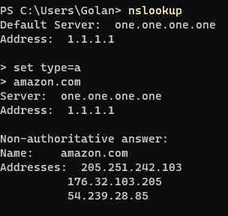

First, I looked for amazon.com ip directly



And, down the rabbit hole we go. With no recursive nslookup

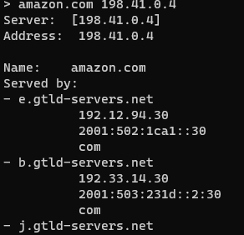

I asked the root ip of a.root-servers.net who what server to ask for amazo.com ip

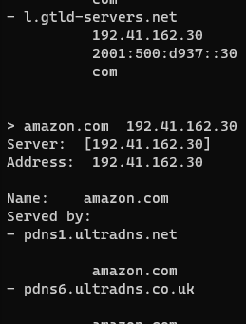

One more server down

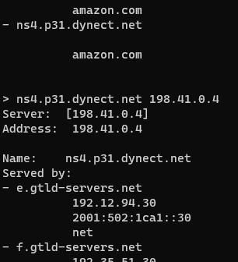

I don’t know this server ip, lets check it out with root first

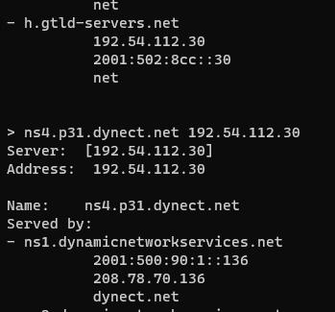

One more server down

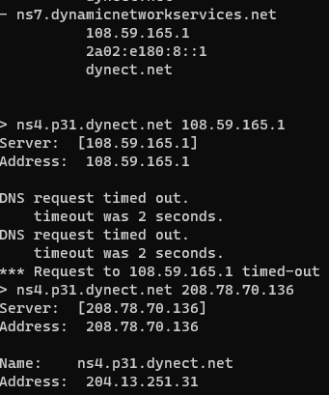

One server timed out so I tried another from the same list

Found the server ip!

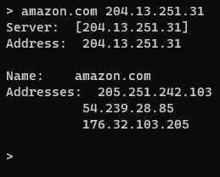

And found amazon.com ip!



And it returned the same ip as we fond in the start.